**Step1: Install WinRM on Windows**

WinRM is a feature introduced with Windows Vista that allows management scripts to run remotely. To set it up, we need to download a .ps1 file from a GitHub repository and run it using PowerShell. The name of the script is: “ConfigureRemotingForAnsible.ps1” Repository <https://github.com/ansible/ansible-documentation/blob/devel/examples/scripts/ConfigureRemotingForAnsible.ps1>

After running this file on our Windows device, we are greeted with a screen that looks like the one below: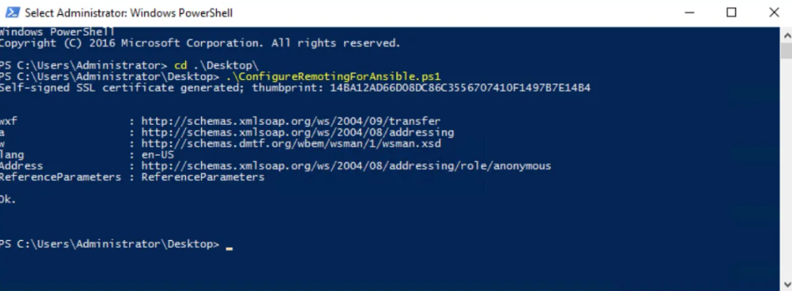

If you see this screen, it means the process has been completed successfully. Note: The win_psexec module can help you enable WinRM on multiple machines if you have many Windows hosts to set up in your environment. After that, you need to have Python installed on your system. You can get it from the Microsoft Store. I used Python 3.10.11.

**Step 2: Lets install Pywinrm**

Ansible’ın kurulu olduğu makinede, terminale “pip install pywinrm” komutunu çalıştırıp yükleme işlemini gerçekleştirebiliriz.

**Step 3: Envanter dosyasını doğru hazırlama:**

In order to connect properly to our Windows host machine, we need to create the inventory file correctly. We must include “ansible_connection=winrm” because we’ll be connecting via WinRM. Below is an example of a properly formatted inventory file:

[win]

172.16.2.5

172.16.2.6

[win:vars]

ansible_user=vagrant

ansible_password=password

ansible_connection=winrm

ansible_winrm_server_cert_validation=ignore

**Step 4: Connection Test**

ansible [host_group_name_in_inventory_file] -i hosts -m win_ping

When we run the above command on the virtual machine where Ansible is installed (after configuring the settings according to our environment), it will attempt to establish a test connection. If the connection is successful, it means the process has completed successfully and our Ansible machine is communicating with the target machine without any issues. An example of a successful connection: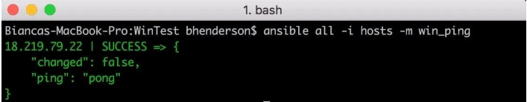

And now, by writing .yml files on the machine where Ansible is installed, creating an .ini inventory file, and providing the necessary configurations, we can successfully manage our Windows machine.

Resources: https://www.redhat.com/en/blog/connecting-to-a-windows-host